# QUESTION1

## a)

library(readr)

SPY <- read_csv("C:/Users/Joey Zhao/Desktop/SPY.csv")

View(SPY)

library(readr)

F_ <- read_csv("C:/Users/Joey Zhao/Desktop/F .csv")

View(F_)

head(df)

# A tibble: 6 x 7

Date Open High Low Close `Adj Close` Volume

<date> <dbl> <dbl> <dbl> <dbl> <dbl> <int>

1 2015-01-02 15.59 15.65 15.18 15.36 13.22856 24777900

2 2015-01-05 15.12 15.13 14.69 14.76 12.71181 44079700

3 2015-01-06 14.88 14.90 14.38 14.62 12.59124 32981600

4 2015-01-07 14.78 15.09 14.77 15.04 12.95296 26065300

5 2015-01-08 15.40 15.48 15.23 15.42 13.28023 33943400

6 2015-01-09 15.46 15.47 15.06 15.21 13.09937 23381300

head(dspy)

# A tibble: 6 x 7

Date Open High Low Close `Adj Close` Volume

<date> <dbl> <dbl> <dbl> <dbl> <dbl> <int>

1 2015-01-02 206.38 206.88 204.18 205.43 194.2749 121465900

2 2015-01-05 204.17 204.37 201.35 201.72 190.7664 169632600

3 2015-01-06 202.09 202.72 198.86 199.82 188.9696 209151400

4 2015-01-07 201.42 202.72 200.88 202.31 191.3244 125346700

5 2015-01-08 204.01 206.16 203.99 205.90 194.7194 147217800

6 2015-01-09 206.40 206.42 203.51 204.25 193.1590 150812300

tail(df)

# A tibble: 6 x 7

Date Open High Low Close `Adj Close` Volume

<date> <dbl> <dbl> <dbl> <dbl> <dbl> <int>

1 2016-12-22 12.63 12.64 12.40 12.40 11.88837 27821100

2 2016-12-23 12.43 12.46 12.36 12.46 11.94590 15578200

3 2016-12-27 12.43 12.51 12.36 12.39 11.87879 19467400

4 2016-12-28 12.37 12.45 12.22 12.25 11.74456 26875400

5 2016-12-29 12.25 12.31 12.22 12.23 11.72539 19714400

6 2016-12-30 12.24 12.28 12.08 12.13 11.62952 27405700

tail(dspy)

# A tibble: 6 x 7

Date Open High Low Close `Adj Close` Volume

<date> <dbl> <dbl> <dbl> <dbl> <dbl> <int>

1 2016-12-22 225.60 225.74 224.92 225.38 222.2119 56219100

2 2016-12-23 225.43 225.72 225.21 225.71 222.5373 36251400

3 2016-12-27 226.02 226.73 226.00 226.27 223.0894 42672500

4 2016-12-28 226.57 226.59 224.27 224.40 221.2457 64095000

5 2016-12-29 224.48 224.89 223.84 224.35 221.1964 47719500

6 2016-12-30 224.73 224.83 222.73 223.53 220.3879 108998300

## b)

Fprice=df$`Adj Close`

SPYprice=dspy$`Adj Close`

n=length(Fprice) # also the rows of SPY

Fret=Fprice[2:n]/Fprice[1:(n-1)]

SPYret=SPYprice[2:n]/SPYprice[1:(n-1)]

head(Fret)

[1] 0.9609374 0.9905150 1.0287276 1.0252660 0.9863814 1.0006576

tail(Fret)

[1] 0.9810125 1.0048388 0.9943820 0.9887005 0.9983672 0.9918235

head(SPYret)

[1] 0.9819403 0.9905811 1.0124611 1.0177452 0.9919864 0.9921664

tail(SPYret)

[1] 0.9982726 1.0014642 1.0024811 0.9917354 0.9997773 0.9963449

## c)

d1=data.frame(SPYret,Fret)

m1=lm(Fret~SPYret)

m1

summary(m1)

Call:

lm(formula = Fret ~ SPYret)

Residuals:

Min 1Q Median 3Q Max

-0.082488 -0.005454 0.000067 0.005830 0.043943

Coefficients:

Estimate Std. Error t value Pr(>|t|)

(Intercept) -0.13631 0.05558 -2.453 0.0145 *

SPYret 1.13584 0.05556 20.444 <2e-16 ***

---

Signif. codes: 0 ‘***’ 0.001 ‘**’ 0.01 ‘*’ 0.05 ‘.’ 0.1 ‘ ’ 1

Residual standard error: 0.01123 on 501 degrees of freedom

Multiple R-squared: 0.4548, Adjusted R-squared: 0.4537

F-statistic: 418 on 1 and 501 DF, p-value: < 2.2e-16

The beta of Ford Motor Co. is 1.13584

Ford’s R^2 is 0.4548, which means this model explains 45.48% of the daily returns of Ford variability

## d)

plot(Fret~SPYret,d1,pch=19,cex=0.6,xlim=c(0.95,1.05),ylim=c(0.95,1.05),col="blue")

abline(m1,lty=2)

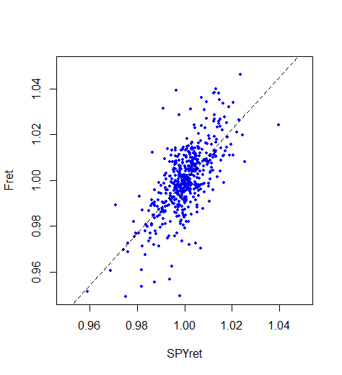

## e)

which.max(residuals(m1))

483

identify(Fret~SPYret)

or we can use this function

text(Fret~SPYret,d1,labels=ifelse(rownames(d1)==483,rownames(d1),""))

the result is the same

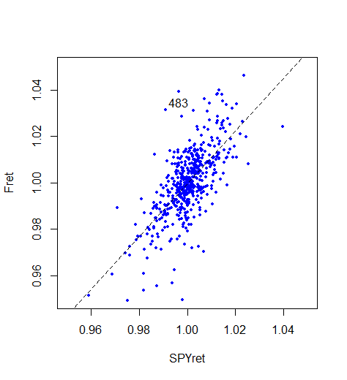

# QUESTION 2

## a)

## i.

insurance <- read_csv("C:/Users/Joey Zhao/Desktop/insurance.csv")

View(insurance)

library(MASS)

d0=insurance

head(d0)

m1=lm(Longevity~.,d0)

m2=stepAIC(m1)

m1

Call:

lm(formula = Longevity ~ ., data = d0)

Coefficients:

(Intercept) Mother Father Gmothers Gfathers Smoker

23.56735 0.30612 0.30301 0.03161 0.07779 -3.71899

m2

Call:

lm(formula = Longevity ~ Mother + Father + Smoker, data = d0)

Coefficients:

(Intercept) Mother Father Smoker

27.2278 0.3344 0.3238 -3.7377

new1=data.frame(Mother=75,Father=65,Smoker=1)

predict(m2,new1,interval="conf")

fit lwr upr

1 69.61732 68.99821 70.23644

## ii.

n=nrow(d0)

n/2

set.seed(2)

train=sample(1:n,50)

m1=lm(Longevity~.,d0[train,])

m2=lm(Longevity~Mother+Father+Smoker,d0[train,])

y=d0$Longevity[-train]

yhat1=predict(m1,d0[-train,])

yhat2=predict(m2,d0[-train,])

MSPE1= mean((y-yhat1)^2)

MSPE2= mean((y-yhat2)^2)

sqrt(MSPE1)

sqrt(MSPE2)

> sqrt(MSPE1)

[1] 2.587677

> sqrt(MSPE2)

[1] 2.519974

The sqrt(MSPE) of m2 ＜The sqrt(MSPE) of m1

Model m2 is better than m1

# QUESIOTN 3

## a)

dim(prices)

C=cor(prices)

View(C)

dim(C)

which(C==max(C) , arr.ind = T)

for(i in 1:452)

C[i,i]=0

which(C==max(C),arr.ind = T)

C[428,205]

names[428,]

names[205,]

> names[428,]

# A tibble: 1 x 3

Ticker Sector Name

<chr> <chr> <chr>

1 VNO Financials Vornado Realty Trust

> names[205,]

# A tibble: 1 x 3

Ticker Sector Name

<chr> <chr> <chr>

1 HST Financials Host Hotels & Resorts

The largest correlation is [1] 0.9901256

## b)

x=prices[,205]

y=prices[,428]

x=as.list(x)

y=as.list(y)

newd=data.frame(y,x)

newd

plot(newd,pch=19,cex=0.6,col="blue")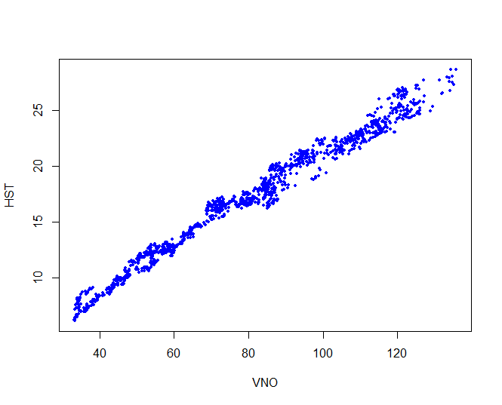

## c)

d2=names

d2$Sector

table(d2$Sector)

Consumer Discretionary Consumer Staples Energy Financials

70 35 37 74

Health Care Industrials Information Technology Materials

46 59 64 29

Telecommunications Services Utilities

6 32

There are 46 health care companies in the full dataset

## d)

d2f=subset(d2,d2$Sector=="Financials")

d2f$Ticker

rows=d2f$`c(1:452)`

rows

colnames(d1)

d1f=d1[,rows]

dim(d1f)

Cf=cor(d1f)

dim(Cf)

which(Cf==max(Cf) , arr.ind = T)

for(i in 1:74)

Cf[i,i]=0

which(Cf==max(Cf),arr.ind = T)

row col

VNO 71 32

HST 32 71

d2f[71,]

d2f[32,]

> d2f[71,]

Ticker Sector Name c(1:452)

428 VNO Financials Vornado Realty Trust 428

> d2f[32,]

Ticker Sector Name c(1:452)

205 HST Financials Host Hotels & Resorts 205